UML - Interaction Diagrams

This interactive behavior is represented in UML by two diagrams known as **Sequence diagram** and **Collaboration diagram**. The basic purpose of both the diagrams are similar.

Sequence diagram emphasizes on time sequence of messages and collaboration diagram emphasizes on the structural organization of the objects that send and receive messages.

The purpose of interaction diagram is −

* To capture the dynamic behaviour of a system.
* To describe the message flow in the system.
* To describe the structural organization of the objects.
* To describe the interaction among objects.

The Sequence Diagram for Order Management System :

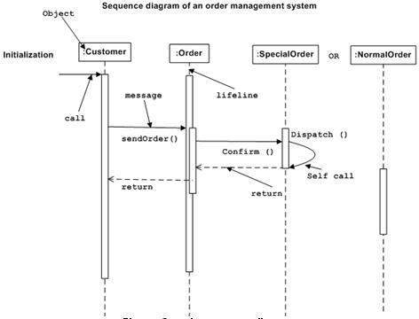

The Collaboration Diagramfor Order Management System :

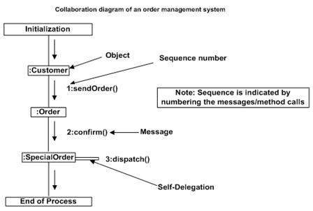

**Collaboration diagram for Online shopping system**

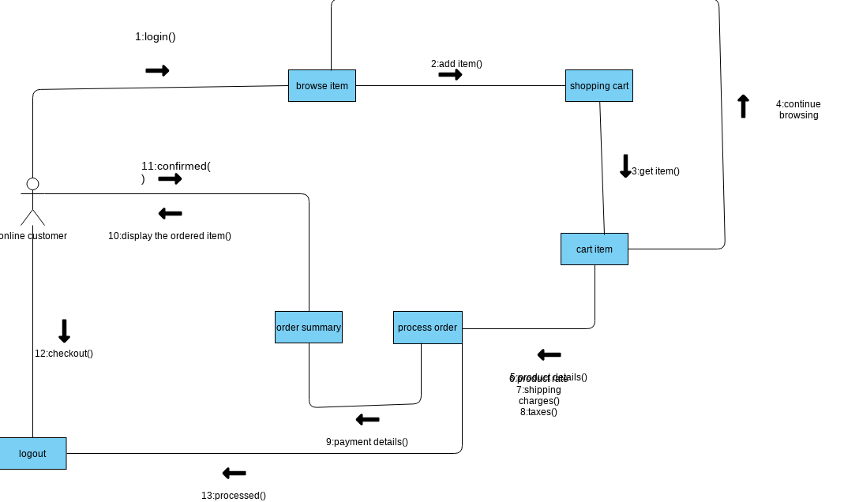

Sequence Diagram - Online Shopping System

